MOOD, ANXIETY, DISSOCIATIVE, AND PERSONALITY DISORDERS

MOOD EPISODES

- Major depressive episode. For at least 2 weeks, the patient is in an extremely depressed mood and has problems with eating and sleeping, feelings of worthlessness and guilt, trouble concentrating, anhedonia, and recurrent thoughts about death.
- Manic episode (Mania). For at least 1 week, the patient feels elated (or sometimes only irritable) and may be grandiose, talkative (may have a flight of ideas), hyperactive, restless (or requires little sleep) and distractible. Bad judgment leads to marked social or work impairment; often patients must be hospitalized (e.g engaging in unrestrained buying sprees, sexual indiscretions, or foolish business investments).
- Hypomanic episode (Hypomania). Less severe form of mania that typically lasts 4 days.

BIPOLAR AND RELATED DISORDERS

- Bipolar I – experience of a full manic episode.
  - Psychotic features: Hallucination & Delusion present during manic or depressive episode
- Bipolar II – presence of hypomania and 1 major depressive episode.
  - Psychotic features: Hallucination & Delusion present during depressive episode
- Cyclothymic Disorder (Cyclothymia) – chronic mood swings for at least 2 years but do not meet the severity and criteria of manic and major depressive episodes
- Substance/Medication-Induced Bipolar and Related Disorder – Manic or hypomanic symptoms developed during or soon after substance intoxication or withdrawal or after exposure to a medication
- Bipolar and Related Disorder due to another Medical Condition - Persistent period of manic mood that is thought to be related to the direct physiological effects of another medical condition.

DEPRESSIVE DISORDERS

- Major Depressive Disorder. Extremely depressed mood for at least 2 weeks and the absence of manic or hypomanic episodes.
- Persistent Depressive Disorder (Dysthymia). A depressed mood that continues at least 2 years, differs from a major depressive disorder in the number of symptoms required, but mostly it is in the chronicity.
- Disruptive Mood Dysregulation Disorder. A child’s severe irritability and difficulty regulating their emotions resulting in frequent temper outburst.
- Premenstrual Dysphoric Disorder. A few days before her menses, a woman experiences symptoms of depression and anxiety that affects social or work functioning.
- Substance/Medication-induced Depressive Disorder. Depressive symptoms developed during or soon after substance intoxication or withdrawal or after exposure to a medication.
- Depressive Disorder due to another Medical Condition. Persistent period of depressed mood that is thought to be related to the direct physiological effects of another medical condition.

- Other Specified, or Unspecified Depressive Disorder. Depressive symptoms are present that cause impairment in important areas of functioning but do not meet the full criteria for any of the depressive disorders.

Specifiers
- Psychotic features - psychotic symptoms, specifically hallucinations and delusions.
- Anxious distress - high levels of anxiety have been associated with higher suicide risk, longer duration of illness, and greater likelihood of treatment nonresponse.
- Mixed features – manic/hypomanic symptoms present during major depressive episodes.
- Melancholic features – severe somatic symptoms (weight loss, early morning awakenings) and anhedonia.
- Catatonic features - excessive but random or purposeless movement.
- Atypical features - oversleeping and overeating during depressive episodes.
- Peripartum onset - A manic, hypomanic, or major depressive episode (or a brief psychotic disorder) can occur in a woman during pregnancy or within a month of giving birth.
- Seasonal pattern- episodes that occur during certain seasons.

Causes of Mood Disorders

Biological
- genetic factors contribute to the susceptibility of an individual to develop a disorder.
- Low levels of serotonin is associated with depression.
- high levels of cortisol are evident in patients with depression.
- sleep disturbances are a hallmark of most mood disorders

Psychological
- Stressful life events are strongly associated with the onset of mood disorders.
- Seligman suggests that people become anxious and depressed when they decide that they have no control over the stress in their lives (learned helplessness theory of depression).
- Beck suggested that depression may result from a tendency to think negatively about themselves, their immediate world, and their future (depressive cognitive triad)

Social and Cultural
- Disruptions in relationships often lead to depression.
- Gender differences in the development of emotional disorders are strongly influenced by perceptions of uncontrollability
- Social influences may also affect the psychological and biological functioning of an individual.
- the risk of depression for people who live alone is almost 80% higher than for people who live with others

Treatments for Mood Disorders

- Medications
  - Antidepressants: selective-serotonin reuptake inhibitors (SSRIs) e.g fluoxetine, mixed reuptake inhibitors e.g venlafaxine, tricyclic antidepressants e.g amitriptyline, and monoamine oxidase (MAO) inhibitors
  - lithium carbonate, also referred as “mood-stabilizing drug” is effective in preventing and treating manic episodes.
- Electroconvulsive Therapy - the most controversial treatment for psychological disorders, there is some evidence that ECT increases levels of serotonin, blocks stress hormones, and promotes neurogenesis in the hippocampus.

- Transcranial Magnetic Stimulation (TMS) - works by placing a magnetic coil over the individual’s head to generate a precisely localized electromagnetic pulse.
- Cognitive Behavioral Therapy – developed by Aaron Beck, clients are taught to contemplate their thought process and help manage it by changing the way they think in a much less depressing way.
- Interpersonal Psychotherapy - focuses on resolving problems in existing relationships and learning to form important new interpersonal relationships.
- Maintenance Treatment – prevention of relapse or recurrence, it may be a combination of taking medications and psychological treatment such as CBT.

ANXIETY DISORDERS

Anxiety is a negative mood state characterized by bodily symptoms of physical tension and by apprehension about the future (American Psychiatric Association, 2013; Barlow, 2002)
- Anxiety is anticipation of future threats. (muscle tension and vigilance)
- Fear is the emotional response to real or perceived imminent threat (fight or flight);
- Panic is the sudden overwhelming reaction
- Panic attack is defined as a sudden experience of intense fear or discomfort, accompanied by physical symptoms that usually include heart palpitations, chest pain, shortness of breath, and dizziness.
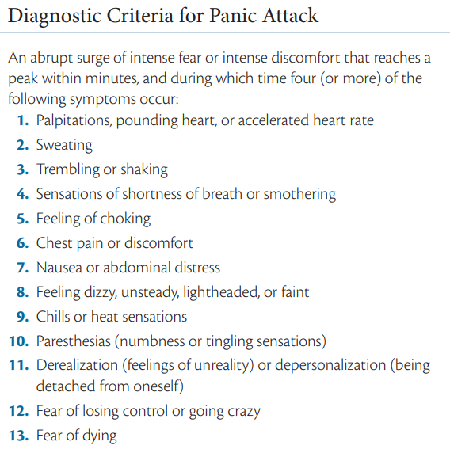

Types of Panic Attack

- Situationally bound (cued) panic attack – The panic is bound to a specific stimulus. Ex. If you know you are afraid of high places or of driving over long bridges, you might have a panic attack in these situations but not anywhere else.
- Unexpected (uncued) panic attacks – No stimulus can determine the panic attack. Ex. if you don’t have a clue when or where the next attack will occur.
- Situationally predisposed panic attack – Between cued and uncued types. You are more likely to, but will not inevitably, have an attack where you have had one before

Causes of Anxiety and Related Disorders

Biological
- Behavioral Inhibition System – activated by signals from the brain stem of unexpected events, such as major changes in body functioning that might signal danger; activation of this system leads to anxiety and frustration
- Fight or Flight System – produces an immediate alarm-and-escape response
- Fear Circuit of the Brain – amygdala is activated and the medial prefrontal cortex appears to help regulate amygdala activity
- Imbalance of Neurotransmitters – persons with anxiety disorders have low levels of GABA and Serotonin, while Norepinephrine is higher than normal levels.

Psychological
- Behavioral theorists thought anxiety was the product of early classical conditioning, modeling, or other forms of learning.
- Anxiety sensitivity, which appears to be an important personality trait, determines who will and who will not experience problems with anxiety under certain stressful conditions.
- A sense of control (or lack of it) that develops from these early experiences is the psychological factor that makes us more or less vulnerable to anxiety in later life.

Social
- Stressful life events such as marriage, divorce, difficulties at work, death of a loved one, pressures to excel in school, and so on. Some might be physical, such as an injury or illness.

GENERALIZED ANXIETY DISORDER

GAD is characterized by muscle tension, mental agitation, susceptibility to fatigue, some irritability, and difficulty sleeping.
- People with GAD are persistently worried, even about minor things. They worry about relationships, health, finances, and daily nuisance, and eventually cause distress or impairment in their daily life.
- Common among adults (45 y.o and above)
- Some reports onset in early adulthood.
- “free-floating”
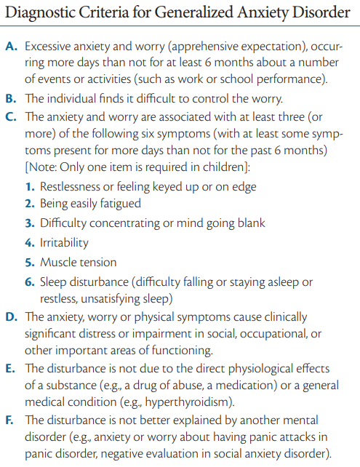

Causes of GAD
- Generalized biological vulnerability – inherited tendency to become anxious
- Several studies have found that individuals with GAD have been called autonomic restrictors since they show less responsiveness on most physiological measures, such as heart rate, blood pressure, skin conductance, and respiration rate than do individuals with other anxiety disorders.
- Generalized psychological vulnerability - highly sensitive to threat
- Left frontal lobe activation

Treatment of GAD
- Benzodiazepines are most often prescribed for generalized anxiety.
- Antidepressants
- Cognitive-behavioral Treatment (CBT)
- Meditation and mindfulness-based approaches

PANIC DISORDER AND AGORAPHOBIA

In Panic Disorder, individuals experience severe, unexpected panic attacks; they may think they’re dying or otherwise losing control

Agoraphobia is a disorder that is characterized by fear and avoidance of situations in which a person feels unsafe and unable to escape to get home or to a hospital in the event of a developing panic, panic-like symptoms, or other physical symptoms
- The term agoraphobia was coined by Karl Westphal, a German physician, which refers to fear of the marketplace.

Causes of Panic Disorder
- Generalized biological vulnerability – generally neurobiologically overactive to the events of daily life
- Behavioral factor - Classical conditioning of panic attacks in response to bodily
sensations have been called interoceptive conditioning: a person experiences somatic signs of anxiety, which are followed by the person’s first panic attack; panic attacks then become a conditioned response to the somatic changes.
- The influential cognitive theories of David Clark (1986, 1996) emphasizes the specific psychological vulnerability of people with this disorder to interpret normal physical sensations in a catastrophic way.

Treatment of Panic Disorder
- Medications:
  - benzodiazepines, selective-serotonin reuptake inhibitors (SSRIs) such as Prozac and Paxil, and serotonin-norepinephrine reuptake inhibitors (SNRIs)
- Psychological intervention
  - Exposure-based treatments
  - Panic control treatment (PCT) – the therapist uses exposure techniques that convinces the client to deliberately elicit the sensations associated with panic.
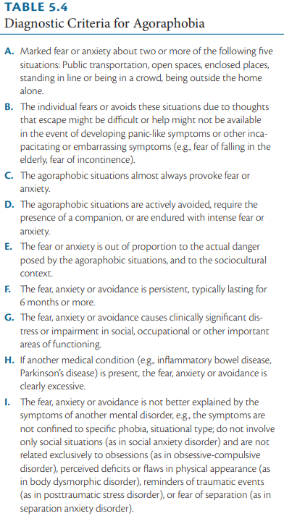

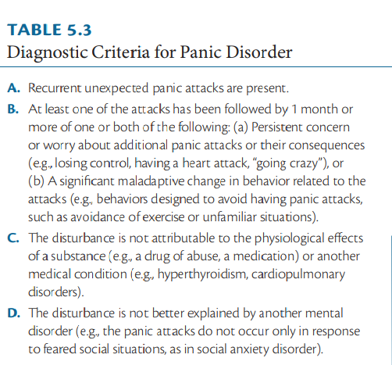

SPECIFIC PHOBIA

A specific phobia is an irrational fear of a specific object or situation that markedly interferes with an individual’s ability to function. Fear and anxiety were out of proportion to any actual danger.
- Blood–injection–injury Phobias – average onset is approx. 9 years, inherited strong vasovagal response to blood, injury, or the possibility of an injection, all of which cause a tendency to faint
- Situational Phobias - characterized by fear of public transportation or enclosed places. Onset is mid-teens to mid-20s, cued panic attacks
- Natural Environment Phobias – e.g heights, storms, and water; fears also seem to cluster together, associated with real dangers; peak age of onset of about 7 years
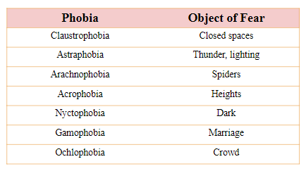
- Animal Phobias - fears of animals and insects (e.g dogs, snakes, mice), peak age of onset of about 7 years

Causes of Specific Phobia

- Traumatic conditioning experience
- Prepared learning - inherited tendency to fear situations that have always been dangerous to the human race
- Susceptible to developing anxiety about the possibility that the event will happen again.
- Social and cultural factors are strong determinants of who develops and reports a specific phobia.

SEPARATION ANXIETY DISORDER

Separation anxiety disorder is characterized by children’s unrealistic and persistent worry that something will happen to their parents or other important people in their life.

Children often refuse to go to school or even to leave home, not because they are afraid of school but because they are afraid of separating from loved ones.

SOCIAL ANXIETY DISORDER

Marked fear or anxiety about one or more social situations in which the person is exposed to possible scrutiny by others. Examples include social interactions (e.g., having a conversation; meeting unfamiliar people), being observed (e.g., eating or drinking), or performing in front of others (e.g., giving a speech). In Japan, taijin kyofusho is the fear of offending others.

POST TRAUMATIC STRESS DISORDER

Exposure to a traumatic event (e.g witnesses death or threatened death, actual or threatened serious injury, or actual or threatened sexual violation). Learning that the traumatic event occurred to a close family member or friend, or enduring repeated exposure to details of a traumatic event (as in first responders to a terrorist attack dealing with human remains) are also setting events.
- Avoidance
- Having flashback
- restriction or numbing of emotional responsiveness

OBSESSIVE-COMPULSIVE DISORDER

Obsessions are intrusive and mostly nonsensical thoughts, images, or urges that the individual tries to resist or eliminate.
Compulsions are the thoughts or actions used to suppress the obsessions and provide relief.

Symmetry obsessions account for most obsessions (26.7%), followed by “forbidden thoughts or actions” (21%), cleaning and contamination (15.9%), and hoarding (15.4%)

Specifiers:
- With good or fair insight: the individual recognizes that obsessive-compulsive disorder beliefs are definitely or probably not true or that they may or may not be true.
- With poor insight: The individual thinks obsessive-compulsive disorder beliefs are probably true.
- With absent insight/delusional: the person is completely convinced that obsessive-compulsive disorder beliefs are true.
- Tic-related: The individual has a current or past history of a tic disorder

BODY DYSMORPHIC DISORDER

Preoccupation with some imagined defect in appearance by someone who actually looks reasonably normal.
- “imagined ugliness”

causes clinically significant distress or impairment in social, occupational, or other important areas of functioning because they think they are so ugly to interact with others and that others will make fun of their physical appearance.

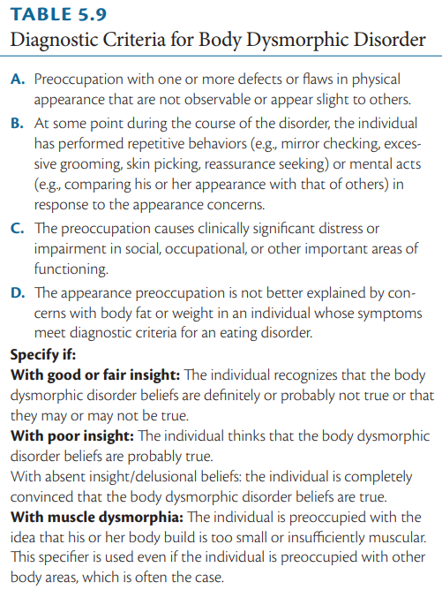

OTHER OBSESSIVE-COMPULSIVE AND RELATED DISORDER

- Hoarding Disorder - experience strong anxiety and distress about throwing anything away, because everything has either some potential use or sentimental value in their minds, or simply becomes an extension of their own identity.
- Trichotillomania (Hair Pulling Disorder) - The urge to pull out one’s own hair from anywhere on the body, including the scalp, eyebrows, and arms
- Excoriation (Skin Picking Disorder) - repetitive and compulsive picking of the skin, leading to tissue damage

PERSONALITY DISORDER

A persistent pattern of emotions, cognitions, and behavior that results in enduring emotional distress for the person affected and/or for others and may cause difficulties with work and relationships. Poor prognosis

- Cluster A is called the odd or eccentric cluster; it includes paranoid, schizoid, and schizotypal personality disorders.
- Cluster B is the dramatic, emotional, or erratic cluster; it consists of antisocial, borderline, histrionic, and narcissistic personality disorders.
- Cluster C is the anxious or fearful cluster; it includes avoidant, dependent, and obsessive-compulsive personality disorders.
- Men diagnosed with a personality disorder tend to display traits characterized as more aggressive, structured, self-assertive, and detached.
- Women tend to present with characteristics that are more submissive, emotional, and insecure
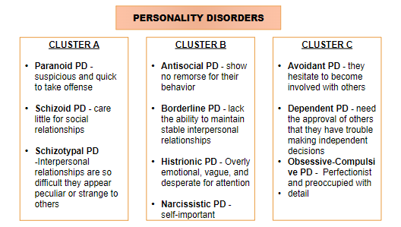

DISSOCIATIVE IDENTITY DISORDER

May adopt as many as 100 new identities, all simultaneously coexisting, although the average number is closer to 15. In some cases, the identities are complete, each with its own behavior, tone of voice, and physical gestures.
- Alters—The different identities
- Host—The identity that keeps other identities together
- Switch—Quick transition from one personality to another
- Dissociative amnesia
- The onset is childhood, often as young as 4 years of age
- Lifelong, chronic course
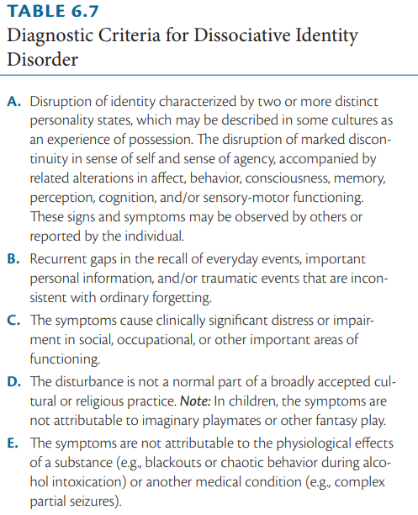

Causes of Dissociative Identity Disorder

- Some people are particularly likely to use dissociation to cope with trauma, and this is seen as a key factor in causing people to develop alters after trauma
- DID may be the result of learning to enact social roles. According to this model, alters appear in response to suggestions by therapists, exposure to media reports of DID, or other cultural influences
- According to the autohypnotic model, people who are suggestible may be able to use dissociation as a defense against extreme trauma

DEPERSONALIZATION-
DEREALIZATION
DISORDER

Depersonalization - your perception alters so that you temporarily lose the sense of your own reality, as if you were in a dream and you were watching yourself.
Derealization - your sense of the reality of the external world is lost. Things may seem to change shape or size; people may seem dead or mechanical.
- Onset is at the age of 16
- Lifelong, chronic course
- High comorbidities: Anxiety, mood, and personality disorders
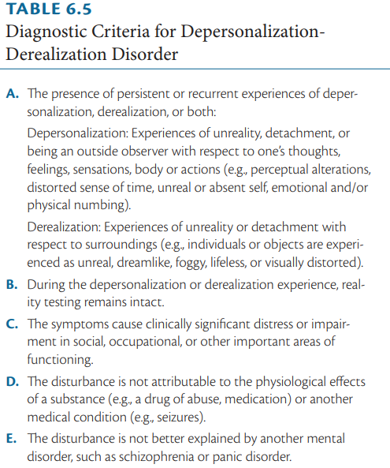

DISSOCIATIVE AMNESIA

Generalized amnesia - unable to remember anything, including their identity; may be lifelong or may extend from a period in the more recent past, such as 6 months or a year previously.

Localized or selective amnesia - failure to recall specific events, usually traumatic, that occur during a specific period

Dissociative fugue – subtype of dissociative amnesia, which refers to individuals who just take off and later find themselves in a new place, unable to remember why or how they got there; “flight”



